 |  |  | Welcome to the Hampton Park Joey Scout Unit  We’re so happy you’ve  decided to join us!!!  This little booklet will help you learn all  about becoming a Joey Scout.
  Your Unit: Your Ideas
  Joeys and Leaders get together at Unit Councils to work out what activities we want to do. Bring all your ideas along. Our activities can be creative, outdoors, personal or community based.   | Plan: What should we do? How should we do it?  Do: Enjoy the activity, include everyone, work together, have fun!  Review: What went well? What didn’t go to plan? What could we do differently next time?
  Special Interest Badges
  Do you like animals, or bike riding, looking after the environment or making things? What about swimming, or inventing or helping other people? Yes! Then there is a badge for you!!!!
  
  The Special Interest badges cover Growth & Development, Environment, Arts & Literature, STEM & Innovation, Adventure & Sport and Creating a Better World.
  These badges can be done as a whole Joey Unit or individually!
  At Joeys we love to: make friends, be active, explore the outdoors, have adventures, learn new things, be creative and have lots of fun!!! | 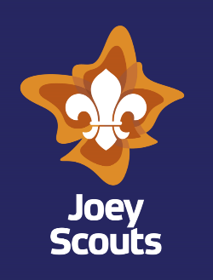
All About Me!  My name is  I am years old  My interests are:  In Joeys Scouts, I want to:  Me! |  | Investiture  Once you decide to join Joeys, there will be a ceremony called an Investiture. You’ll get your scarf, woggle and badges and be welcomed into our Unit. You will make the Scout Promise – you can choose the version you want to use. |  | Scout Law  Be Respectful  Do What is Right  Believe in Myself  Joey Patrols  You will be placed into one of our Patrols. Patrols are flexible so the one you’re in may change. All Joeys will get a chance to be an Assistant Patrol Leader and a Patrol Leader.
  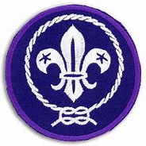
  When you join Scouts, you become part of a worldwide organisation and every Scout around the world wears this badge – just like you!
Scout Promise

On my honour, I promise
to do my best,
to be true to my spiritual beliefs,
to contribute to my community and our world,
to help other people, and
to live by the Scout law

On my honour, I promise
that I will do my best,
to do my duty to my God, and to the Queen of Australia
to help other people, and
to live by the Scout law.
 |  | 
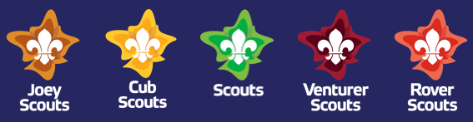
Outdoor Adventure Skills
Joey Scouts love being outdoors and will participate in sleepovers, camps and hikes. When outdoors, Joeys can achieve skills in land based activities – alpine, cycling and vertical challenges – and water based activities – aquatics, boating and paddling. The badges that Joeys earn for these activities become more challenging with time and over the different sections of scouts.
Milestones
As you join in at Joeys, you will earn milestone badges for taking part in activities and for taking turns at leading and helping with the running of the unit meetings.
These badges, along with your special interest badges and your outdoor adventure badges are markers of your journey through scouting and are worn with pride on your uniform.
The Spices
In Scouts, we develop in all of these different areas, through learning by doing things, youth leading, our promise and law, our patrol system, unit councils, community involvement, nature and the outdoors, and our symbolic framework.
 | Social  Friendships Understanding Differences |  | Physical  Adventurous  Healthy  Wellbeing
 | Intellectual  Thinking Planning Creating |  | Character  Do your best  Positive attitude
 | Emotional  Understanding and respecting emotions |  | Spiritual  Reflection Gratitude  Connection

